AS1209: MATRIX COMPUTATION
Report on
Project: Solving Electrical Circuit using SVD based Matrix Computation

BY
Sarthak Pandit (2023Btech072)



JK Lakshmipat University, Jaipur
ODD 2025-26

Title:
Solving Electrical Circuit Using SVD Based on Matrix Computation
[b=Ax →V=IR]

Introduction:
Efficient numerical techniques are frequently needed to solve large circuits with numerous nodes and components in contemporary electrical engineering problems.
This project uses Singular Value Decomposition (SVD) to implement a circuit solver that can handle both consistent and inconsistent systems and analyse resistive networks.
The standard Ohm's Law serves as the foundation for the system:
V = I × R
Where:
V: Vector of voltage (known at nodes)
I: Current vector (problems to be solved)
R: Circuit connectivity resistance matrix
The project shows how SVD can calculate least-squares solutions for inconsistent systems and exact solutions for consistent systems

Methodology:
• Forming the Circuit Matrix:
Each node in the circuit is modeled, and the resistance matrix R is constructed.
Each equation corresponds to KCL/KVL constraints, forming the linear system:
A⋅I=V
Where A = R, I = currents, V = applied voltages
• Applying SVD:
- Decompose the matrix:
A=UΣV^{T}
- U: Orthonormal basis of voltage space (nodes)
- V: Orthonormal basis of current space
- Σ: Singular values representing the stiffness of the circuit
• Solving the System:
- Consistent systems: I=A⁺V gives exact currents
- Inconsistent systems: I=A⁺V gives least-squares currents, minimizing the residual ∣V−AI∣
• Residual and Consistency Check:
- Residual vector: r=V−A⋅I
- Norm of residual: ∥r∥₂​determines if the system is consistent or inconsistent
• Interpretation of Singular Values:
- Large singular values → stiff circuit (strong constraints, well-defined currents)
- Small singular values → near short-circuit or rank-deficient network (ill-conditioned)
Language Used:
- Python

Why SVD?
Typical linear solvers break when:
- Matrix is singular
- Equations are dependent
- Circuit is overdetermined (m > n)
- Circuit is underdetermined (m < n)
- System is inconsistent (no exact solution)
But SVD always works, because every matrix has a decomposition:
- A=UΣV^{T}
The pseudo inverse is:
- A⁺=VΣ⁺U^{T}
This gives a correct:
- Exact solution when consistent
- Least-squares solution when inconsistent
- Minimum-norm solution when underdetermined
This makes SVD the most stable and general-purpose method for solving circuits

Derivation:
Consider a resistive network
Using KCL at each node:
- ∑I_{incoming}=∑I_{outgoing}
Using Ohm’s Law:
- I=(V_{i}−V_{j})/R_{ij}
Substituting currents into KCL gives a linear equation for each node:
- ∑(V_{i}−V_{j})/R_{ij}=I_{inj}
This produces a conductance matrix, which is your matrix A
Thus the equation becomes:
- A.I=V
So in my code:
- A → Resistances / conductances
- x → Currents (I)
- b → Applied voltages (V)
SVD Mathematical Interpretation:
SVD splits the matrix into three parts:
- A=UΣV^{T}

U (Voltage Modes): Columns represent voltage distribution patterns across the network.

V (Current Modes): Columns represent independent current flow patterns.

Σ (Singular Values): Represent the strength of each electrical mode:
- Small σ → Open Circuit (Low Current)
- Large σ → Short Circuit (High Current)
- Zero σ → Dependent equations → Infinite solutions

Pseudo Inverse Formula:
- A⁺=VΣ⁺U^{T}
And therefore:

I=x=A⁺b

A⁺ is the mathematical inverse of resistance matrix when A is not invertible

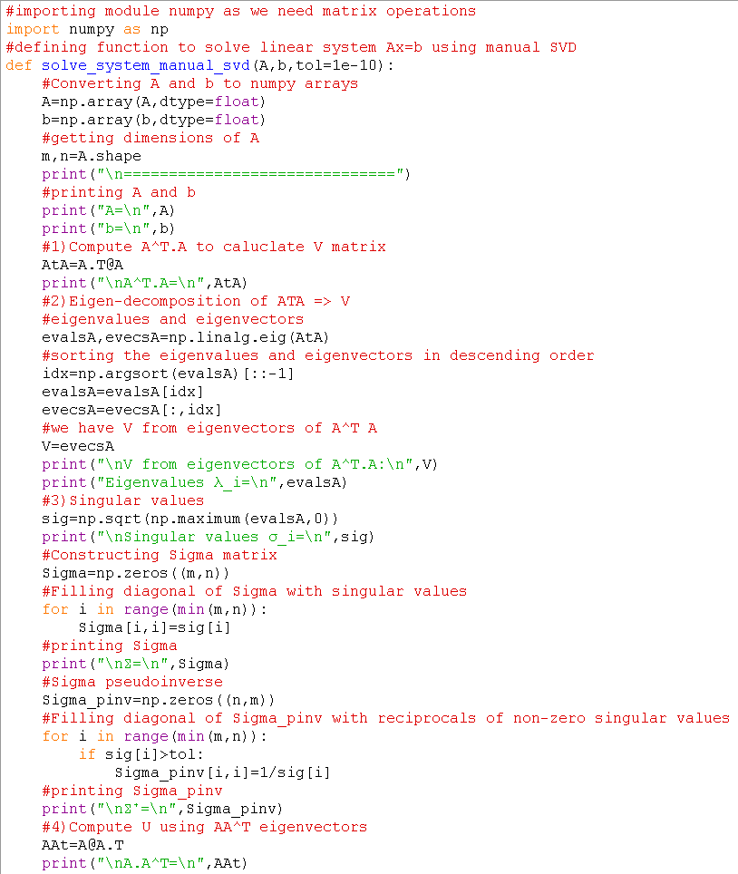
Code:

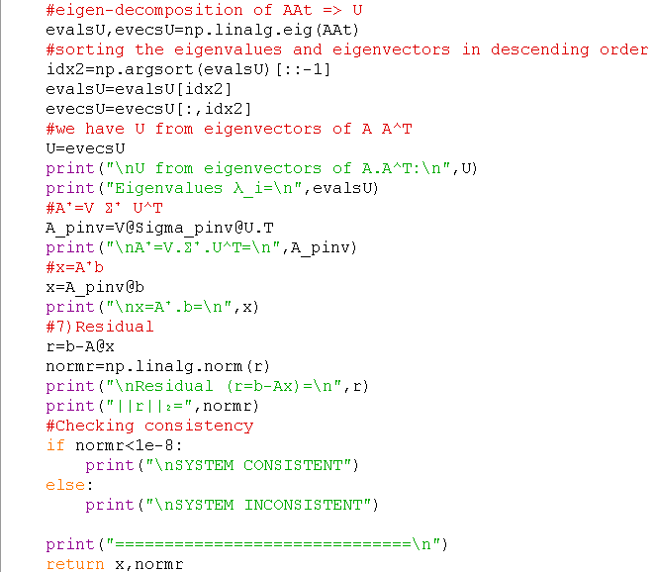

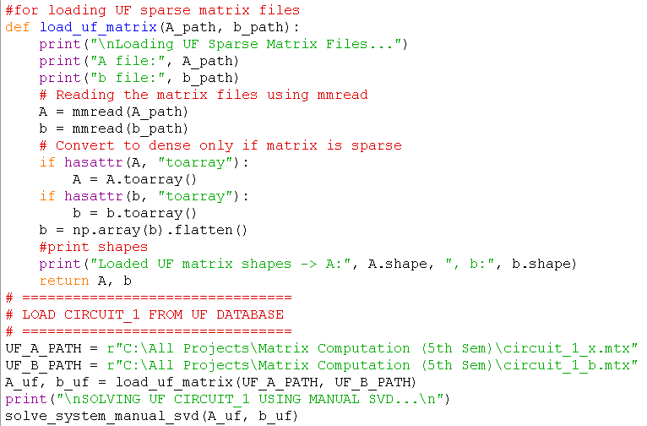

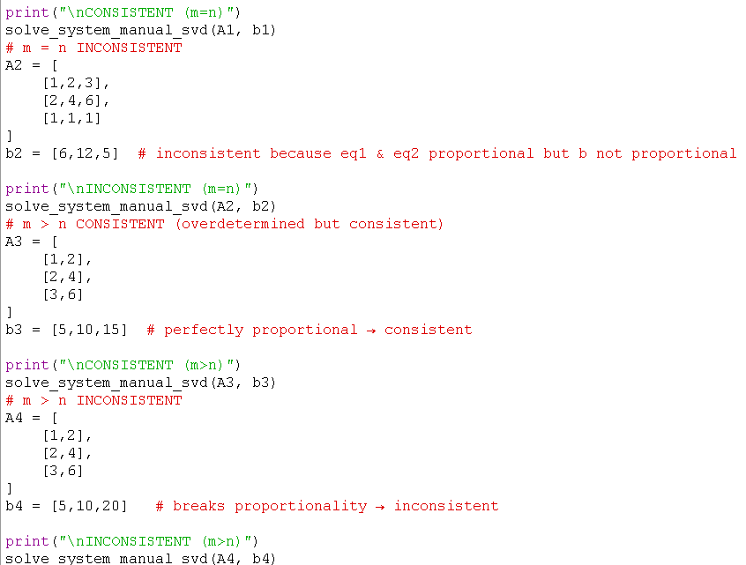

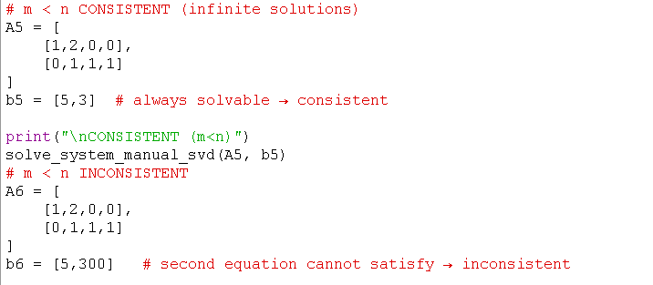

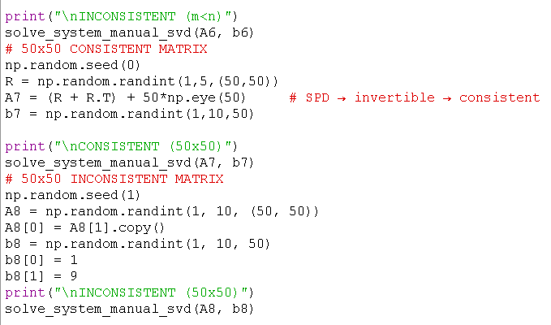

Output:

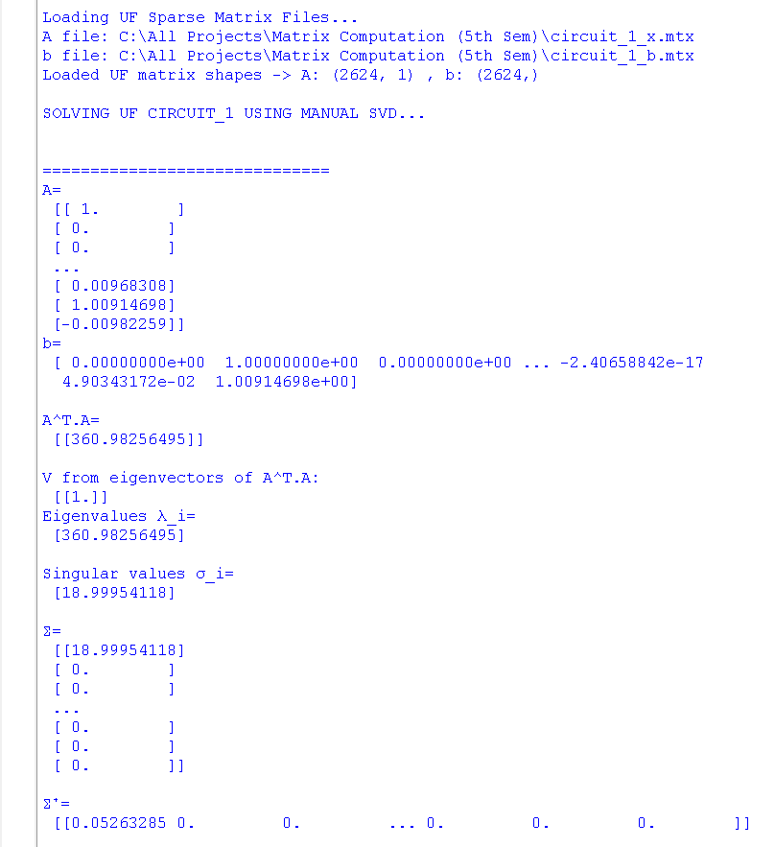
The output for the Matrix taken from University of Florida:

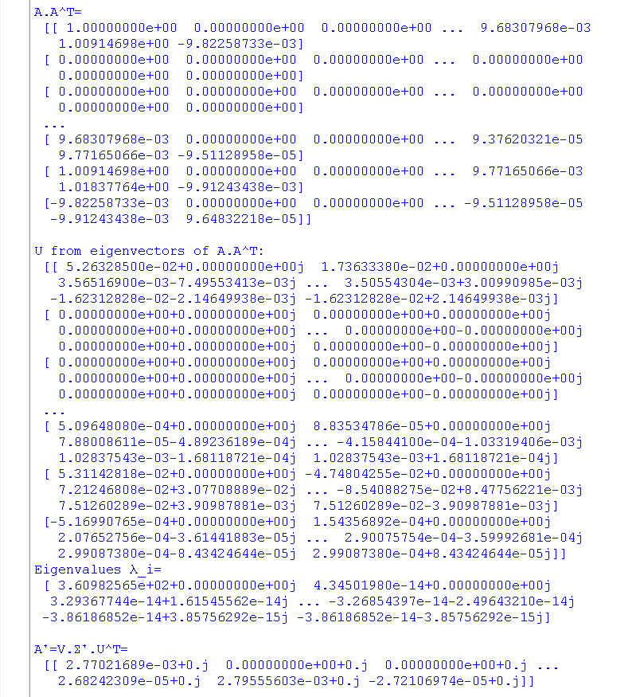

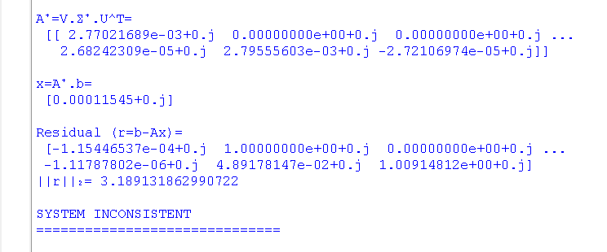

The output for the Matrix hardcoded in the code:

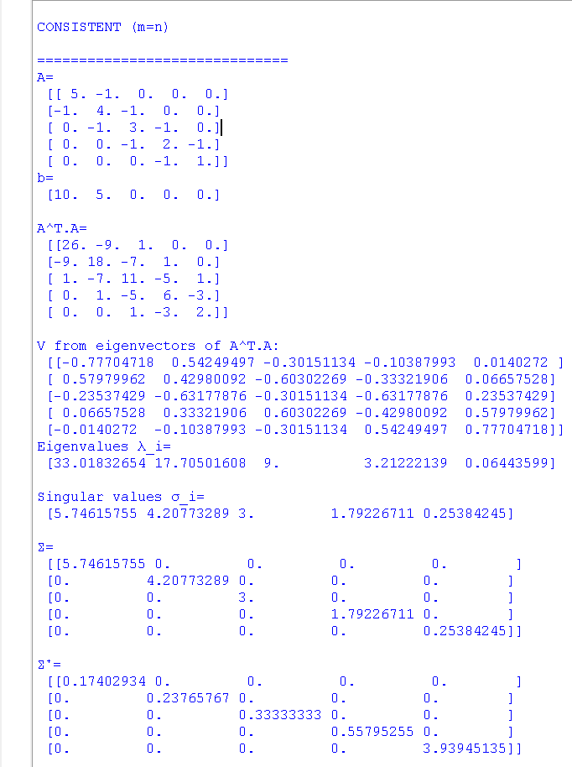

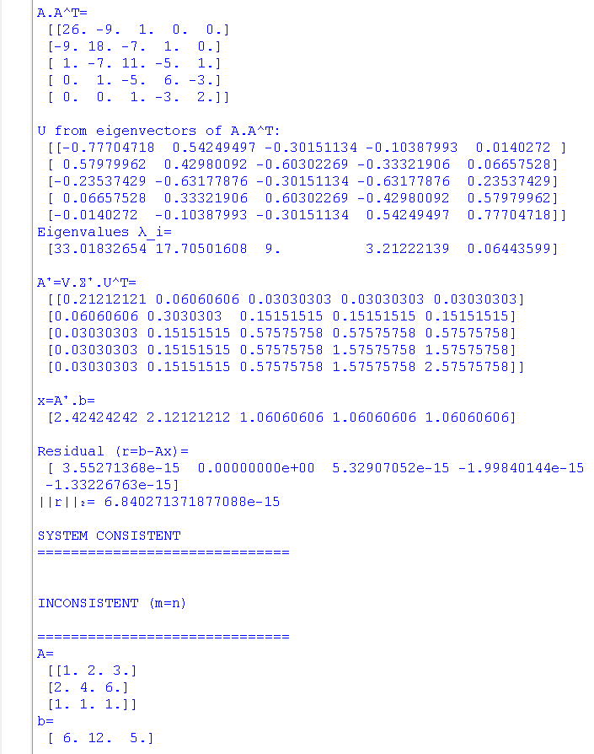

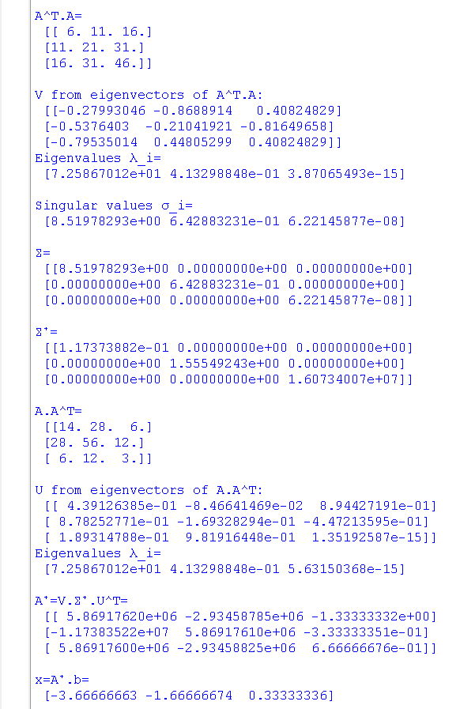

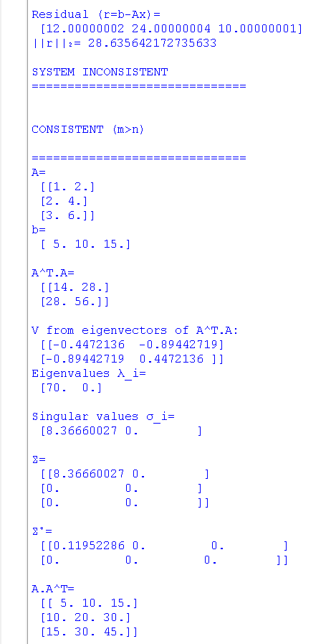

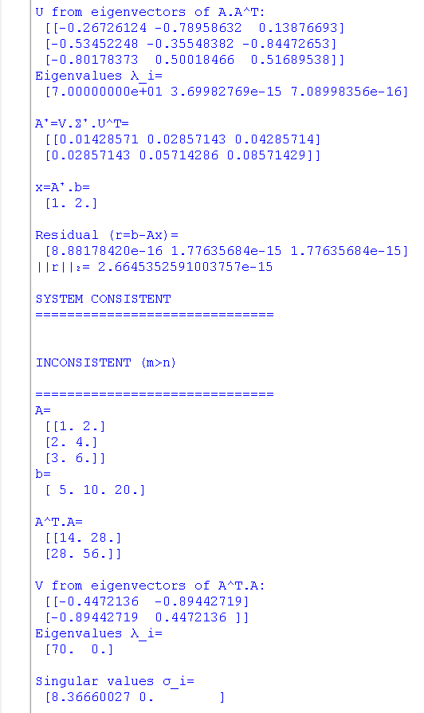

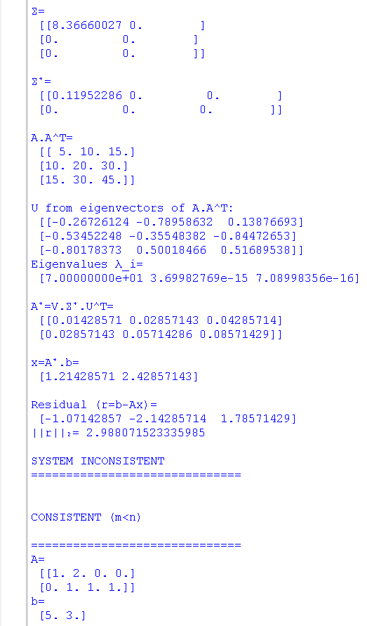

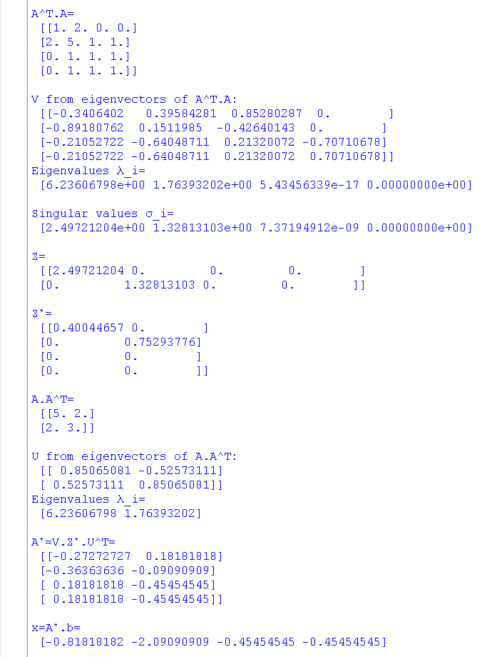

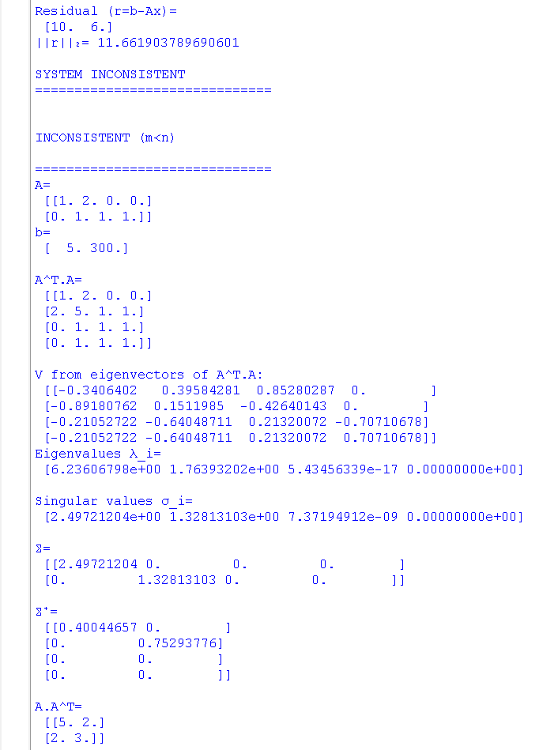

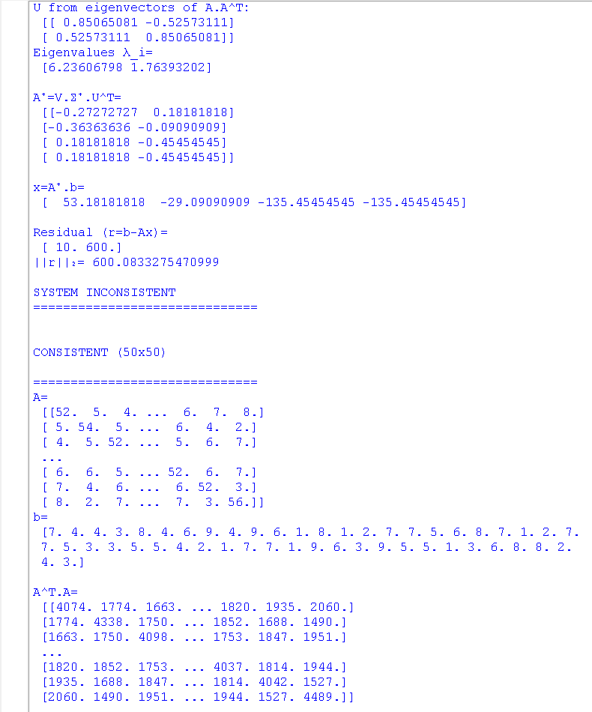

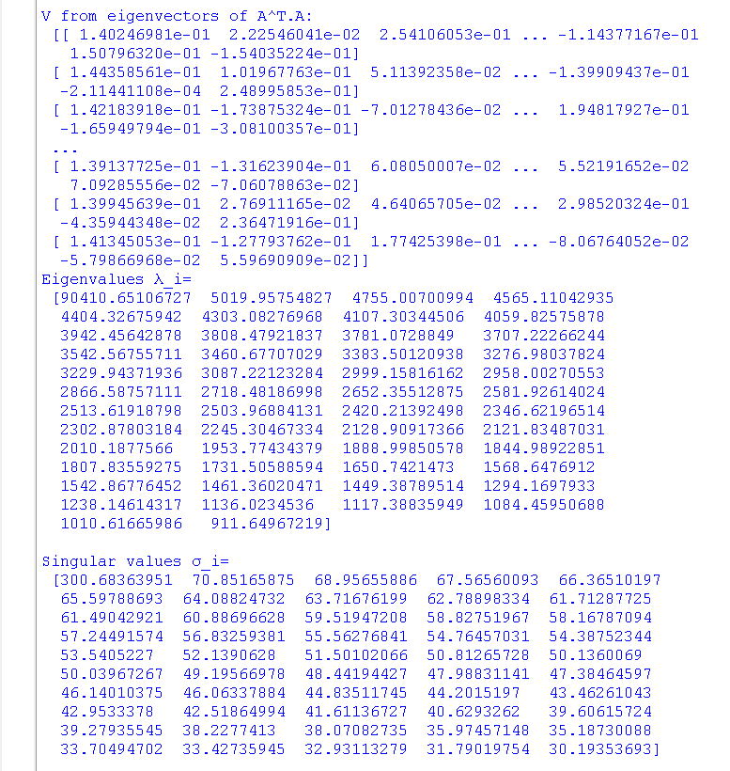

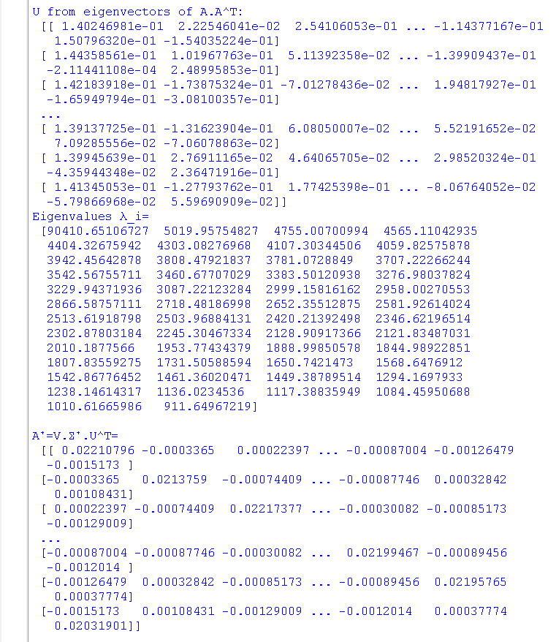

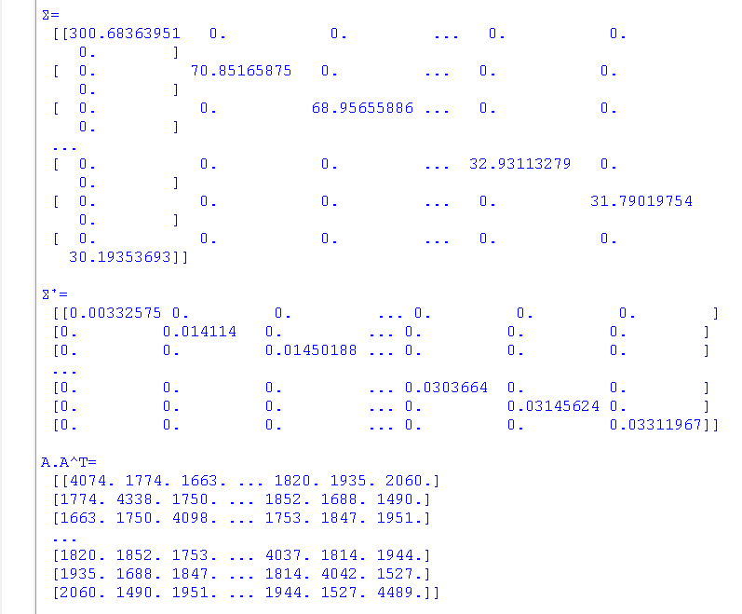

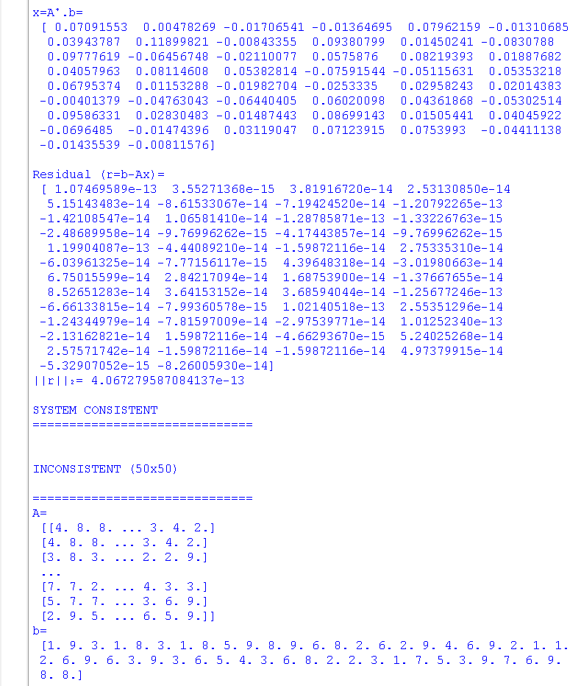

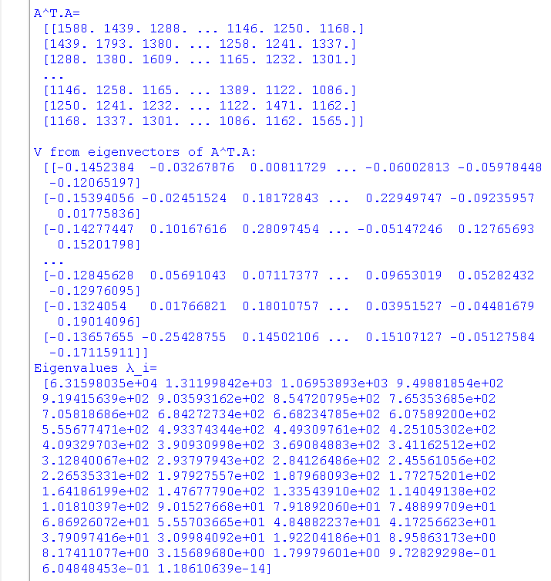

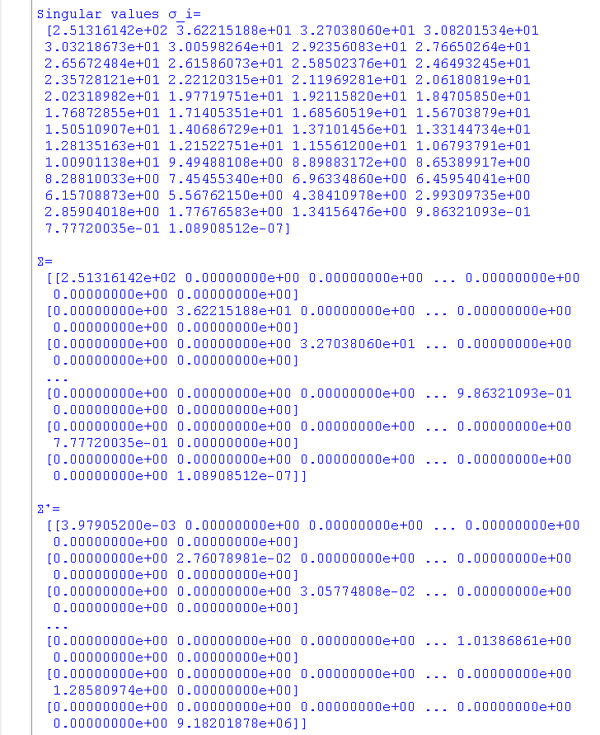

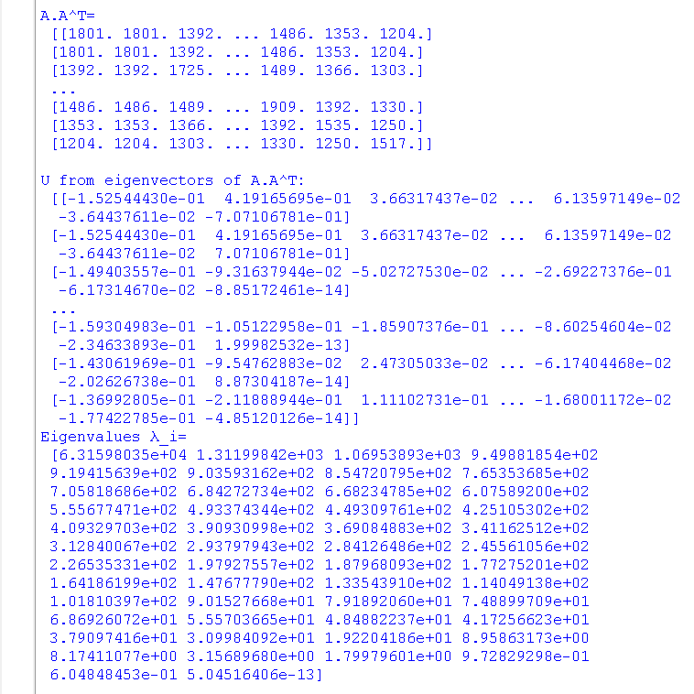

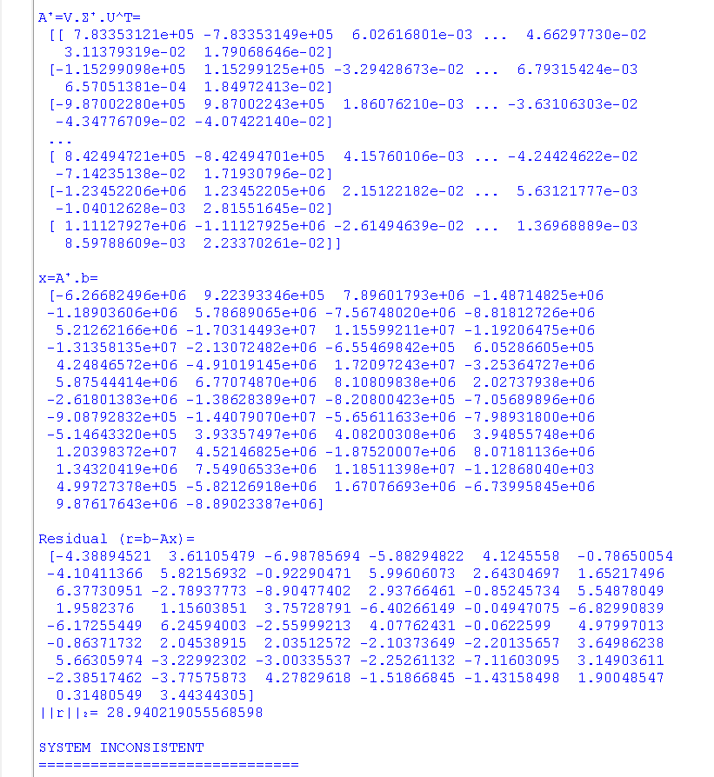

Verification if the Answer Obtained by Code is Correct or Not:
Manual solution for m > n Inconsistent Matrix (A4 Matrix in code)
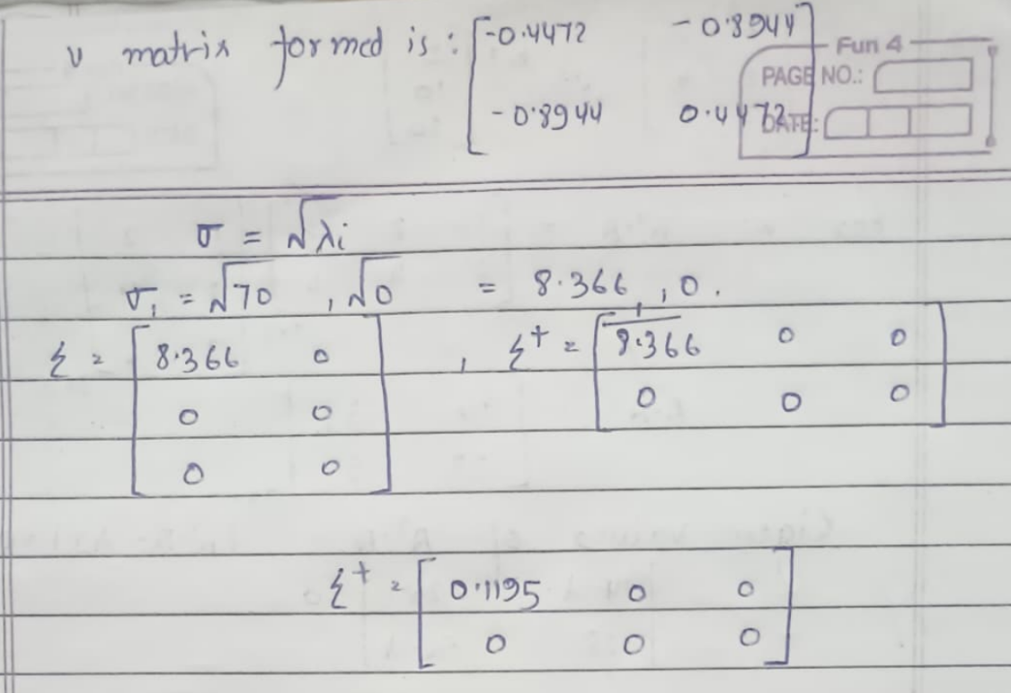
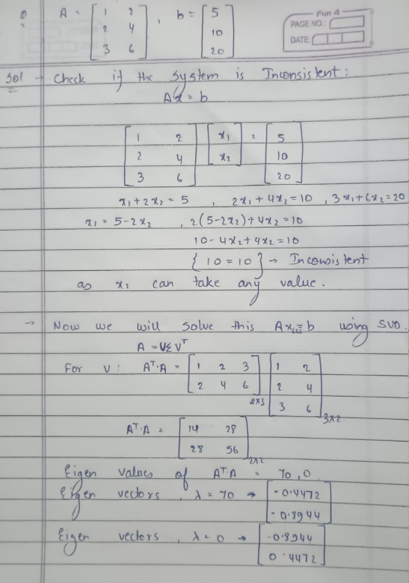

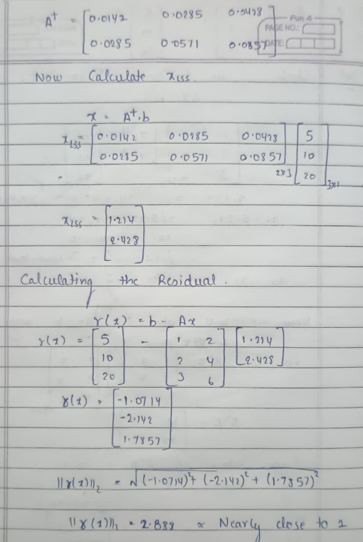
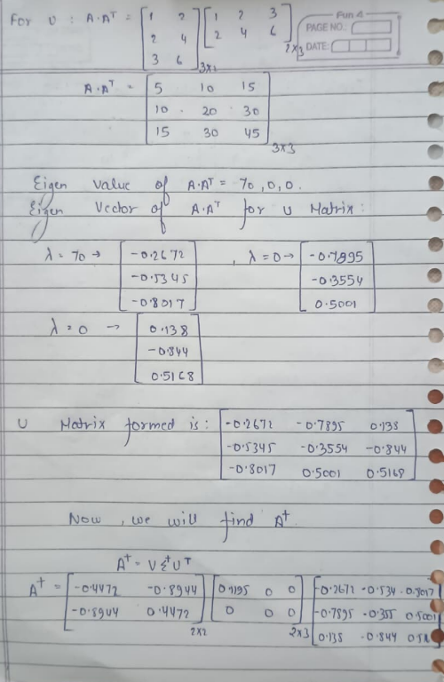

=== END OF REPORT ===

